**LAB ASSIGNMENT-9**

**ADVANCED SOFTWARE ENGINEERING**

**Team ID :**5-2

**Team Members:**

**Name:** Rahul Dhamerla,7

**Name**: Teja Devarapalli,5

**Assignment:**

* Understand the use case.
* Create a login page using PUG Template engine
* On click of login button display details of user by retrieving from cookie in NodeJS
* Load CSS files using express. static () method.
* UI is needed

**Requirements:**

* PUG, Java script, Node, Express.
* Web storm, Git hub.

**Introduction:**

After the successful registration of the user, the details will be saved in Cookie. After the successful login the user will be redirected to a home page where it displays the details of the user stored in cookie.

**Design/Implementation:**

* To create a new directory: npm init
* To Install Express: npm install express –save
* To install pug: npm install PUG –save
* Created Views and public folder to store pug templates and CSS files.

**Output:**

**Register page:**

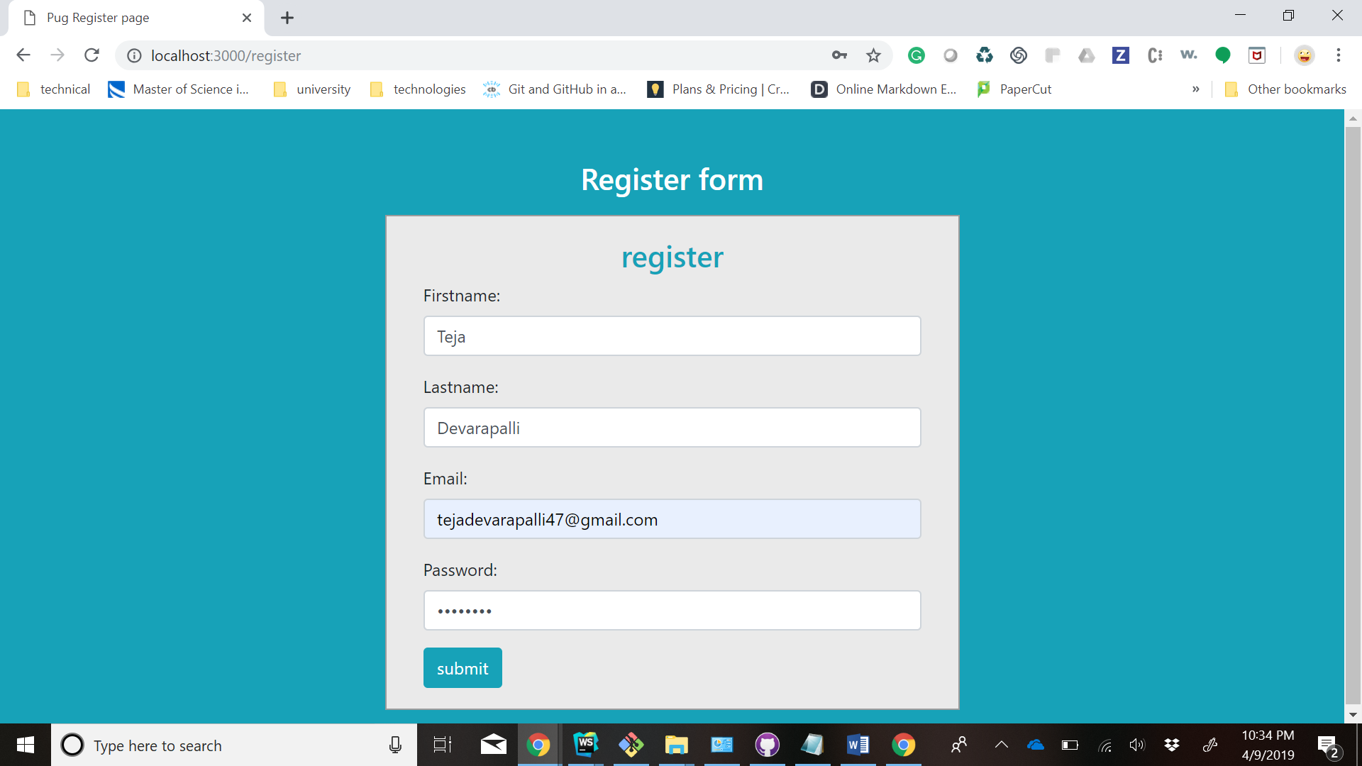

**Login Page:**

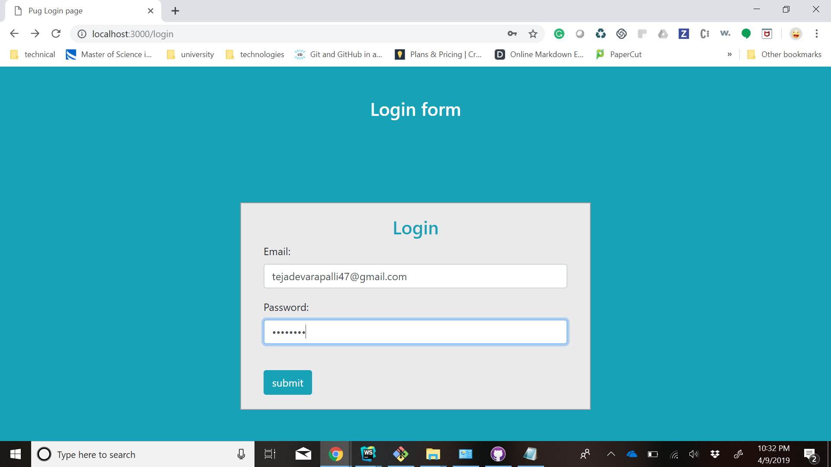

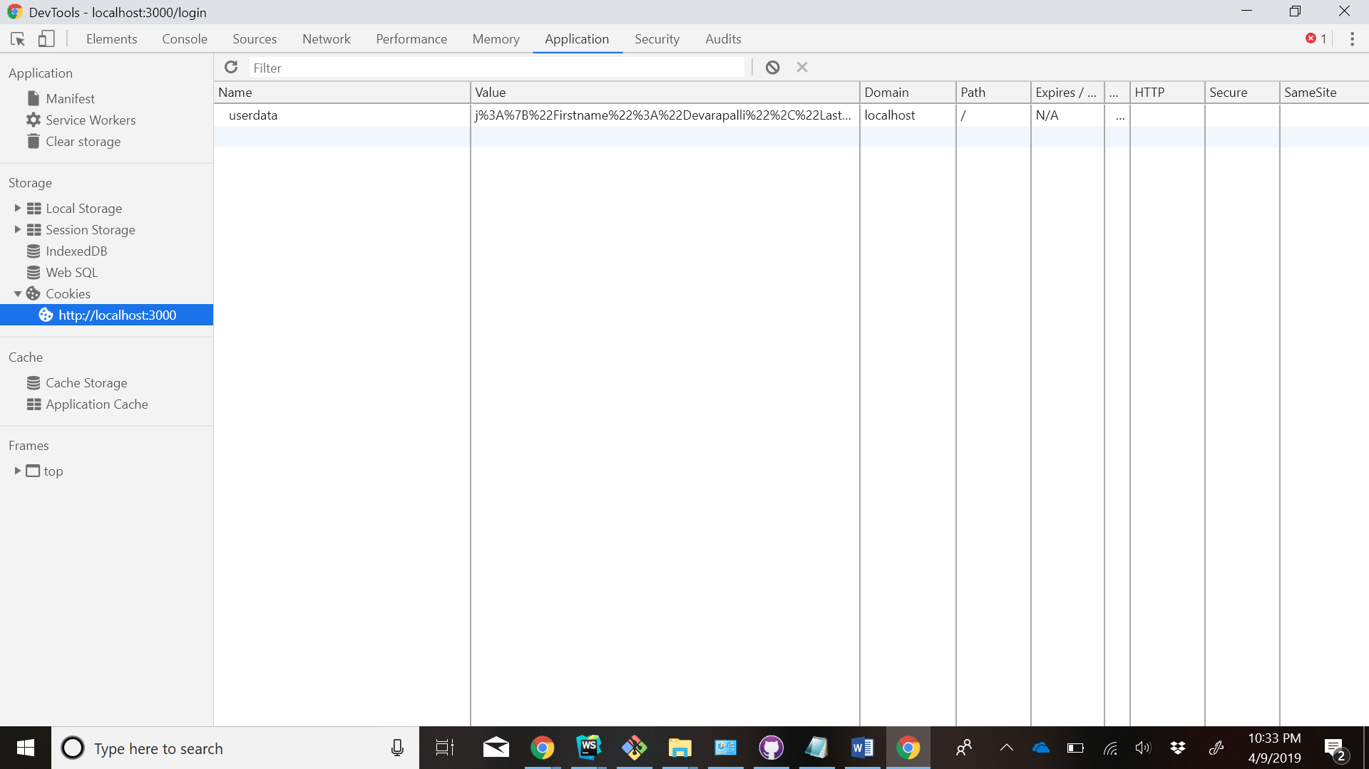

**Home Page Displaying user details:**

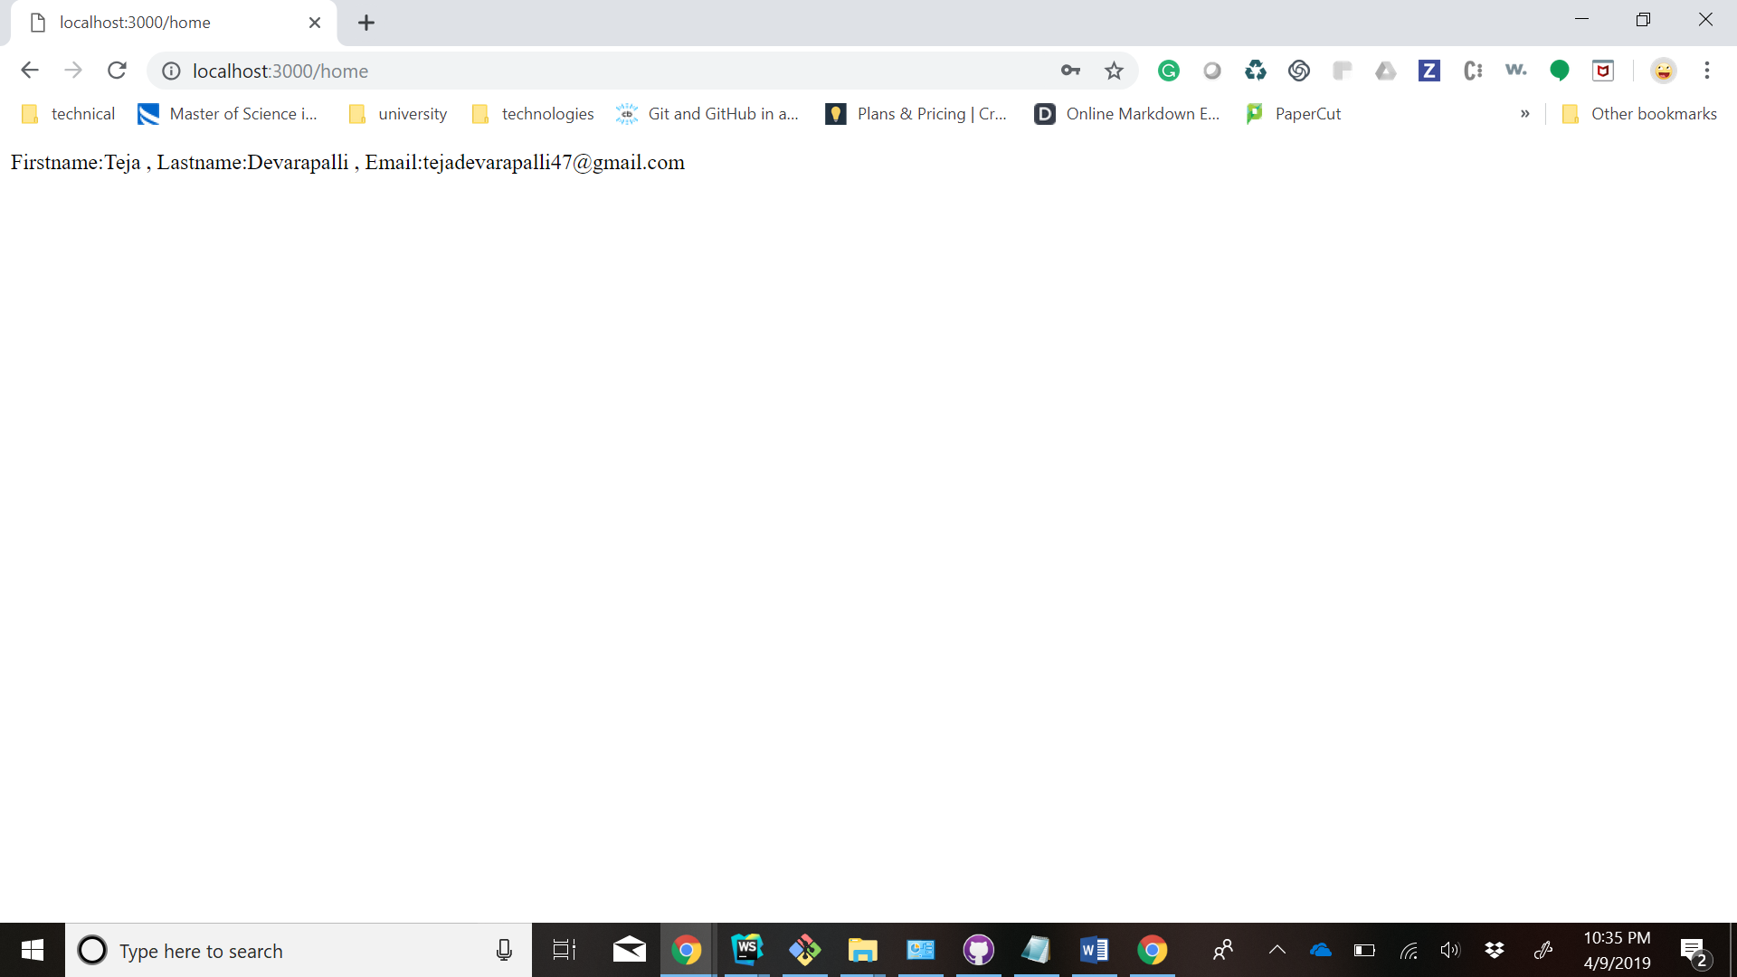

**Contribution:**

**Teja Devarapalli,5:**

* Implemented Register and home page.
* Implemented set and get cookies

**Rahul Dhamerla,7**:

* Implemented Login page.
* Documentation.